HOME
- Change the wording View menus, available items, and order straight from your phone.
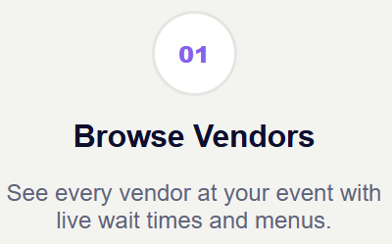

- Now that we have the look and feel sorted on the webapp, please add the screenshots to both the phone mockups at the top and end of the website.
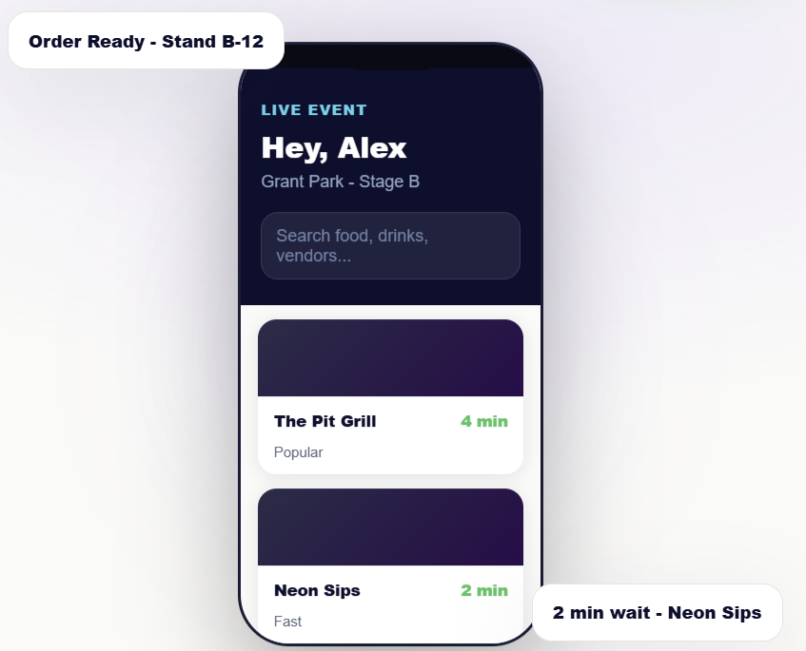

EXPERIENCE

- The mission and the vision is still missing. It was in the OG html I sent. (see the next screenshot as a reminder).
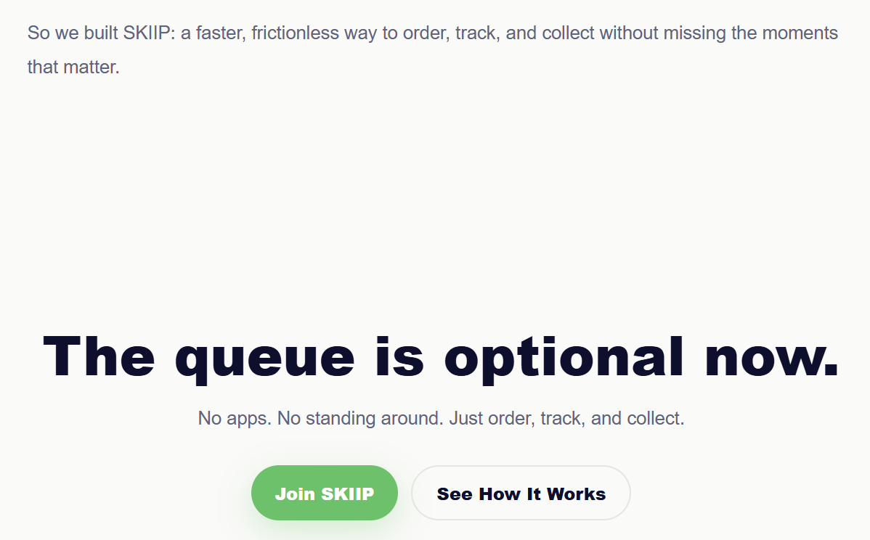
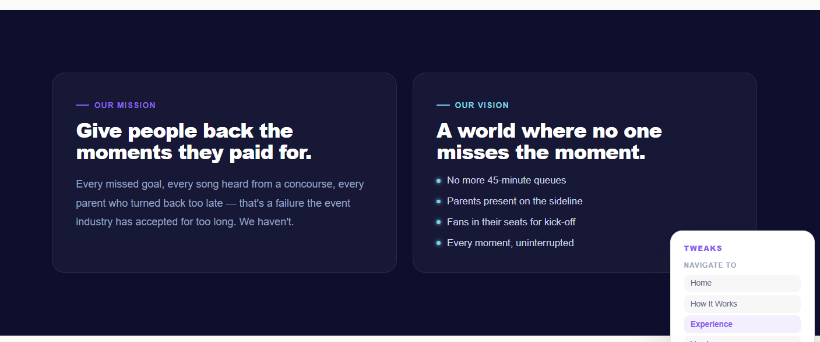

Change the mission wording to: Give people back the moments they came for.
Every missed goal, every song heard from the food line, every moment spent waiting instead of experiencing – that’s the problem SKIIP exists to solve.
We believe live events should feel lived, not queued for.

Change the vision wording to: The queue is optional now.
- No more missing the headline act for food
- Fans in their seats for kick-off
- Parents present on the sideline
- Every moment uninterrupted

- All the forms are still showing this error message
